**CMPE-250 Laboratory Exercise Five**

**Polled Serial I/O**

By submitting this report, I attest that its contents are wholly my individual writing about this exercise and that they reflect the submitted code. I further acknowledge that permitted collaboration for this exercise consists only of discussions of concepts with course staff and fellow students; however, other than code provided by the instructor for this exercise, all code was developed by me.



Dean Trivisani

Performed September 26, 2017

Submitted October 3, 2017

Lab Section 01L2

Instructor: Melton

TA: Donald Mannise

Michael Baumgarten

Matthew Toro

Lecture Section 01

Professor: Melton

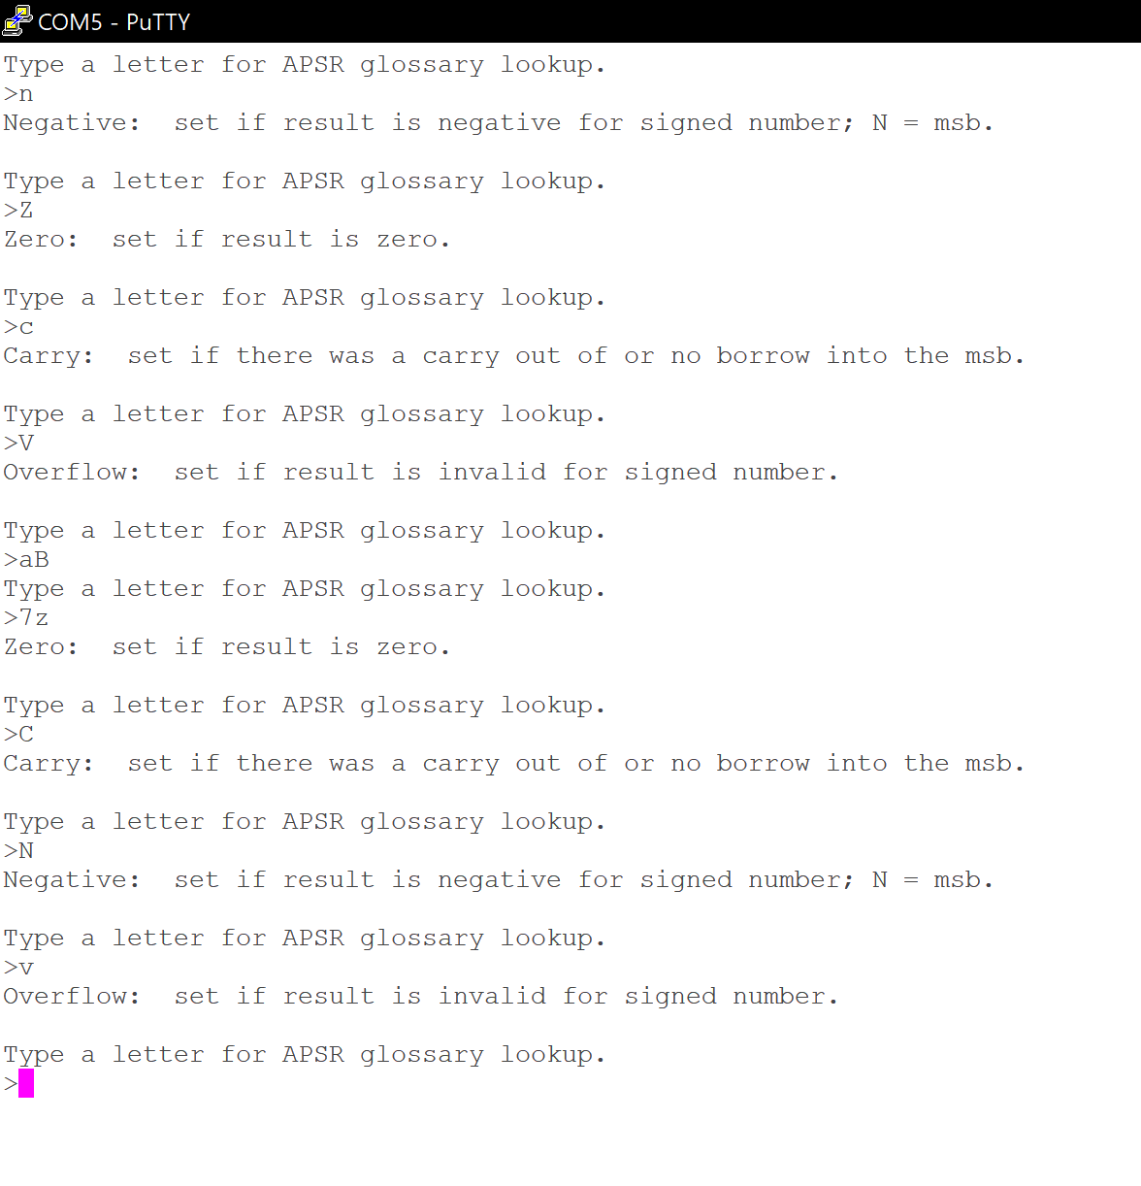

**Question: What is the exact memory range of the executable code?**

The exact memory range can be found by locating the starting value of the MyCode area and adding the size less one to find the end value. The starting value is 0x00000290, and the size is 296, so the end value is 0x0000029016 + 29610 = 0x000003B8, so the memory range is from 0x00000290 to 0x000003B8.